**BLOG: APPLICATIONS OF DATA STRUCTURES IN REAL LIFE**

Hello guys, welcome to my blog. In this article, I will discuss the applications of data structures and algorithms in the real world, here in this article I will share some applications of arrays, stack, linked lists, etc.

Firstly let me give a short definition of, what is Data Structure? A data structure is a way in which data is stored in a computer so that it can be used efficiently. Here I will discuss,

* Applications of arrays
* Applications of stack
* Applications of singly linked list
* Applications of doubly linked list
* Applications of circular linked list
* Applications of graphs
* Applications of queues
* Applications of trees
* Applications of hash table
* Applications of matrix

**Arrays**

The array is a collection of similar types of data items stored in a contiguous memory location.

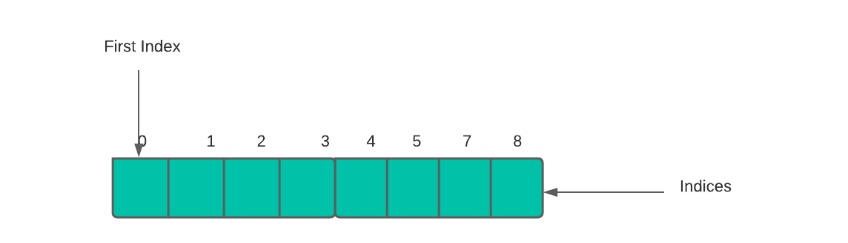

**Applications Of Arrays:**

* The contact application in our phone which we use in our daily life has a lot of contacts. These contacts are stored in the form of an array. When we add or delete a contact it is similar to inserting/deleting an array.
* Similarly, songs playlist in our music player.
* 2-Dimensional Arrays also called Matrix, are used in the processing of an image.
* These are also used in the Online ticket booking system – if a user wants to book a seat in A-9, the array becomes seat[A][9] or seat [1][9].

**Stack**

A stack is defined as a linear list in which insertions and deletions take place at the same end based on the Last-In-First-Out (LIFO) strategy. This end is called the top of the stack and the other end is called the bottom of the stack.

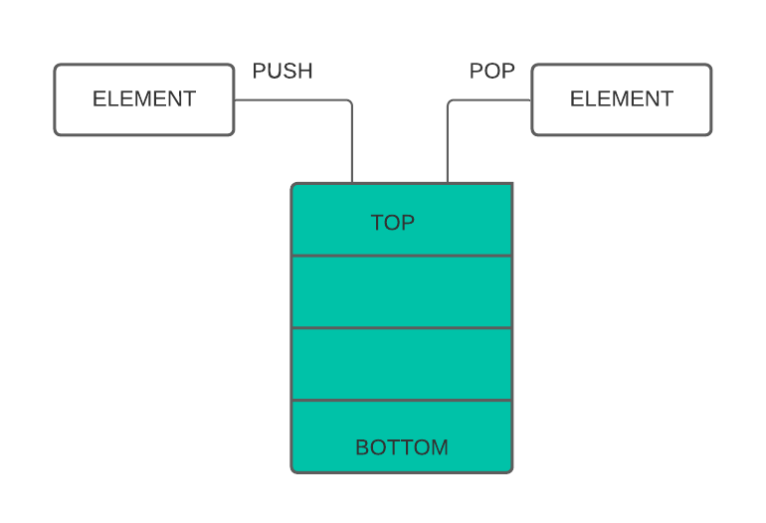

**Applications Of Stack:**

* Stacks are useful for solving many problems in computer science. One of the most important is to store the return address in a function call-return structure of a compiler.
* To check for left and right parenthesis match in an expression.
* To evaluate a postfix expression.
* To convert an infix expression to postfix or suffix expression.

**Singly Linked List**

Collection of elements called nodes that are stored haphazardly in the memory. Node has two parts, one which stores data at a specific address, and the other is a pointer that contains the address of the next node. The last node contains the pointer to NULL.



**Applications Of Singly Linked List:**

* UNDO, REDO or DELETE operations.
* Viewing photos continuously one after the other in a Photo Viewer.
* Skip to the next track option in a music player.

**Doubly Linked List**

It is a type of linked list in which a node contains a pointer to the previous and the next node in a sequence.



**Applications Of Doubly Linked List:**

* It is usually used in card games to represent the deck of cards.
* Undo and Redo functions in notepad or some other applications.
* Implementing backward and forward navigation in the web browsers.
* To play the next track or the previous track on a music player.

**Circular Linked List**

In this type of linked list, the last node of the list has a pointer to the first node of the list.

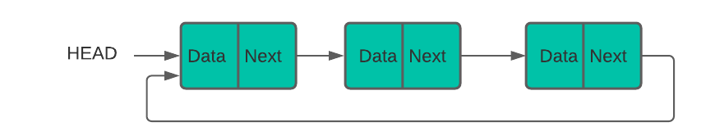

**Applications Of Circular Linked List:**

* It is used in role-based multiplayer games.
* Various mobile games like snake game in which the head of the snake is head of the list and snake’s tail are tail of the list.
* In an operating system, all the running applications are kept in a circular linked list.

**Graphs**

A graph in which every edge is directed is called a digraph. A graph in which every edge is undirected is called an undirected graph or simply a graph.

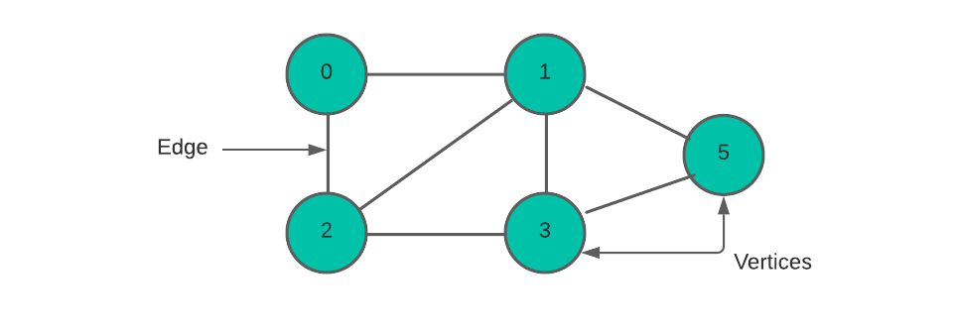

**Applications Of Graph:**

* The shortest path between two points can be found using graphs.
* Used in various e-commerce websites for user preferences.
* Used by Network-based platforms for interconnections.
* Resource management in an organization.

**Queues**

A queue is a linear list in which additions and deletions take place at two different ends. Insertions take place at the rear end and deletions take place in the front end.

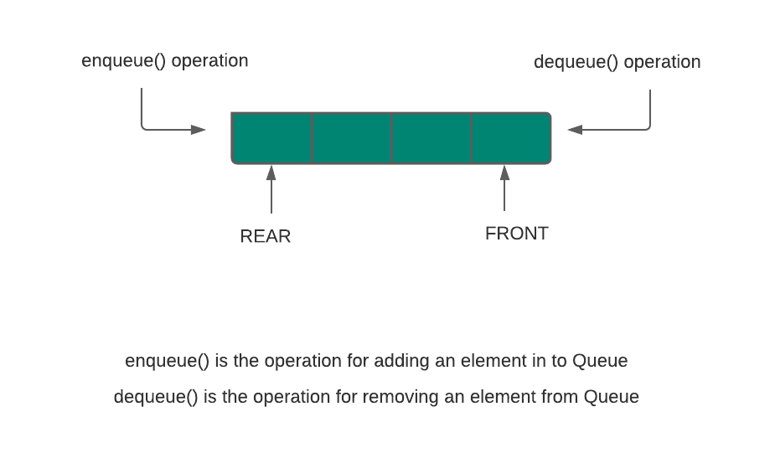

**Applications Of Queues:**

* Priority queues are used in browsers while downloading multiple files.
* Used in call centers where calls of people are put on hold while the person is in another call.
* Used by printer software.
* CPU for task scheduling.

**Trees**

Trees are hierarchical structures that have a single root node.

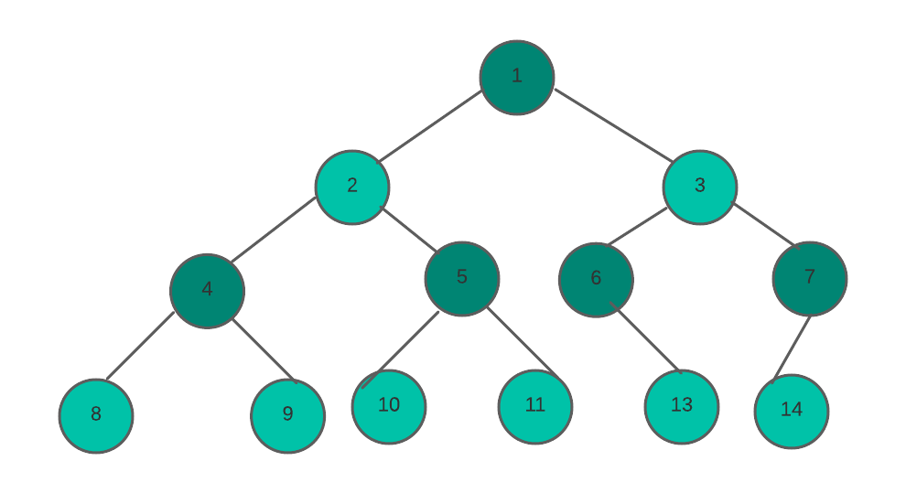

**Applications Of Trees:**

* Implementation of navigation in websites or applications.
* In various games which come across decision-making steps.
* In many computer applications and mobile apps like a file explorer, etc…
* Trees structures are also used in Domain Name Server (DNS).

**Hash Table**

Hash Tables only store data that has a key associated with it. Operations like Inserting and Searching are easily manageable while using Hash Tables.

**Applications Of Hash Table:**

* In web browsers like google chrome, opera, and others, we get desired output based on the principle of Hashing.
* In our computers we have various files stored in it, each file has a filename and file path, for building a connection between the filename to its corresponding file path hash tables are used.

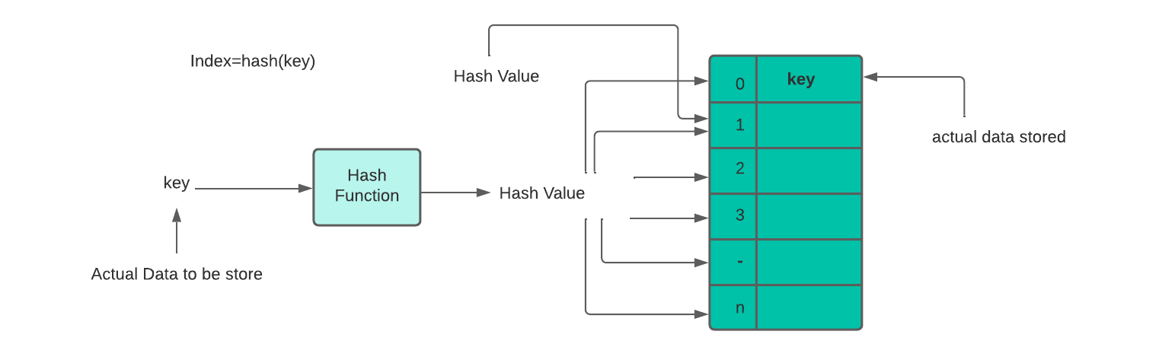

**Matrix**

Matrix is an ordered collection of elements in rows and columns. It is necessary to enclose the elements of a matrix within the square brackets.

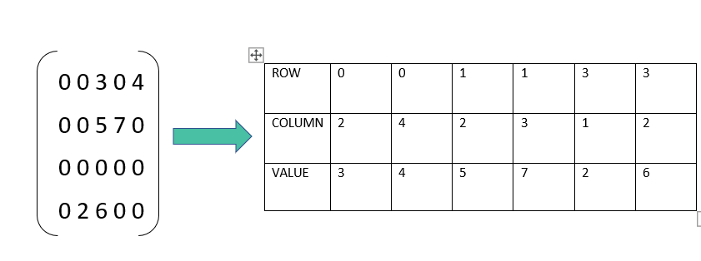

**Applications Of Matrix:**

* It is used for plotting graphs, statistics, and in scientific studies and research fields.
* Matrices are also used in the representation of data like the population of people, mortality rate, etc.

This was about ”**Applications Of Data Structures in real life**“. I hope this article ”**Applications Of Data Structures in real life**” may help you all a lot. Thank you for reading.

By,

**Uma Thakur**

**Bhavin Patil**

**Manasi Patil**

**Chaitanya Patil**